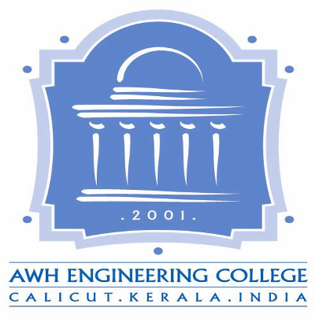

**AWH ENGINEERING COLLEGE**

Calicut

### **CERTIFICATE**

#### This is to certify that this report entitled***“ INNCITY ”*** *submitted herewith is an authentic record of the Project (Phase 1) done by* ***ALEN THOMAS, ANANDHU P P,***

#### ***LIGIN VELLAKKAD, NIKHIL N KURUP, IBRAHIM KHALEEL K*** *under our guidance in partial fulfillment of the requirements for the award of Master of Technology in* ***Computer Science and Engineering*** *from University of Calicut during the academic year 2014-2015.*

**Project Co-ordinator:**

Ms. Janitha Krishnan

Ms. Laiji George

**HoD:**

Mr. Gireesh T K

Associate Professor

Dept. of CSE

**Project Guide:**

Ms. Greeshma K

Assistant Professor

Dept. of CSE